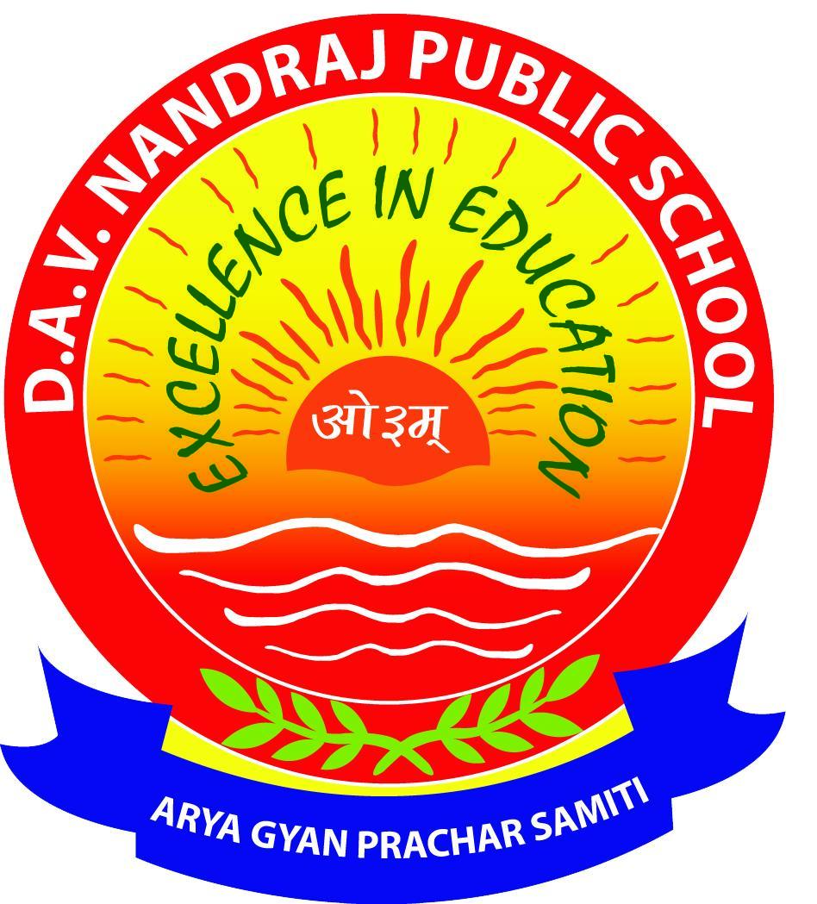
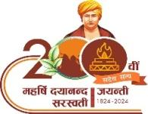
D.A.V. NANDRAJ PUBLIC SCHOOL

BARIATU, RANCHI


HOLIDAY HOMEWORK
SESSION 2026 – 27

CLASS: I

⭐ Dear Parents & Little Champs ⭐
Summer vacation is the perfect time for fun, creativity, and joyful learning! Complete all activities neatly with colours and smiley faces.
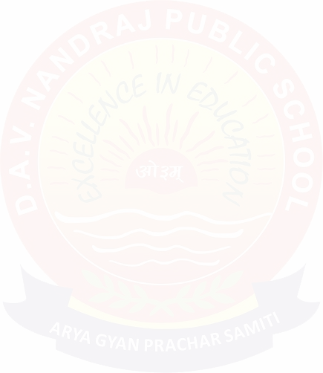
ENGLISH
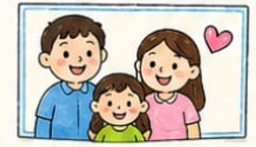

  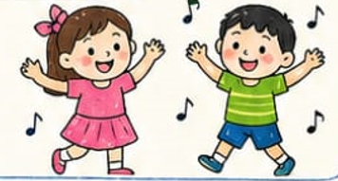  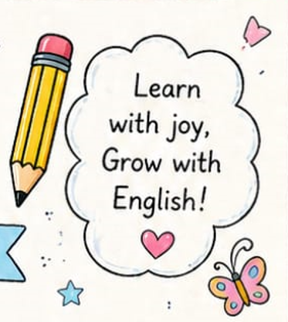 | - Read any English storybook for 10–15 minutes daily.  - Practice A–Z Capital and a–z Small cursive letters.  - Write 1 page handwriting every day.  - Learn and write 10 naming words.  - Paste a family picture and identify He-group & She-group.  - Learn rhymes: "Two Little Hands" and "Hop a Little".

MATHS
I) Draw pictures of the following shapes and colour it according to your choice in a A4 size paper
a) Circle d) Rectangle
b) Square. e)Oval
c) Triangle
II) Practice -Unit 1 : ch 1 to ch 8
III) Learn number names 1 - 50

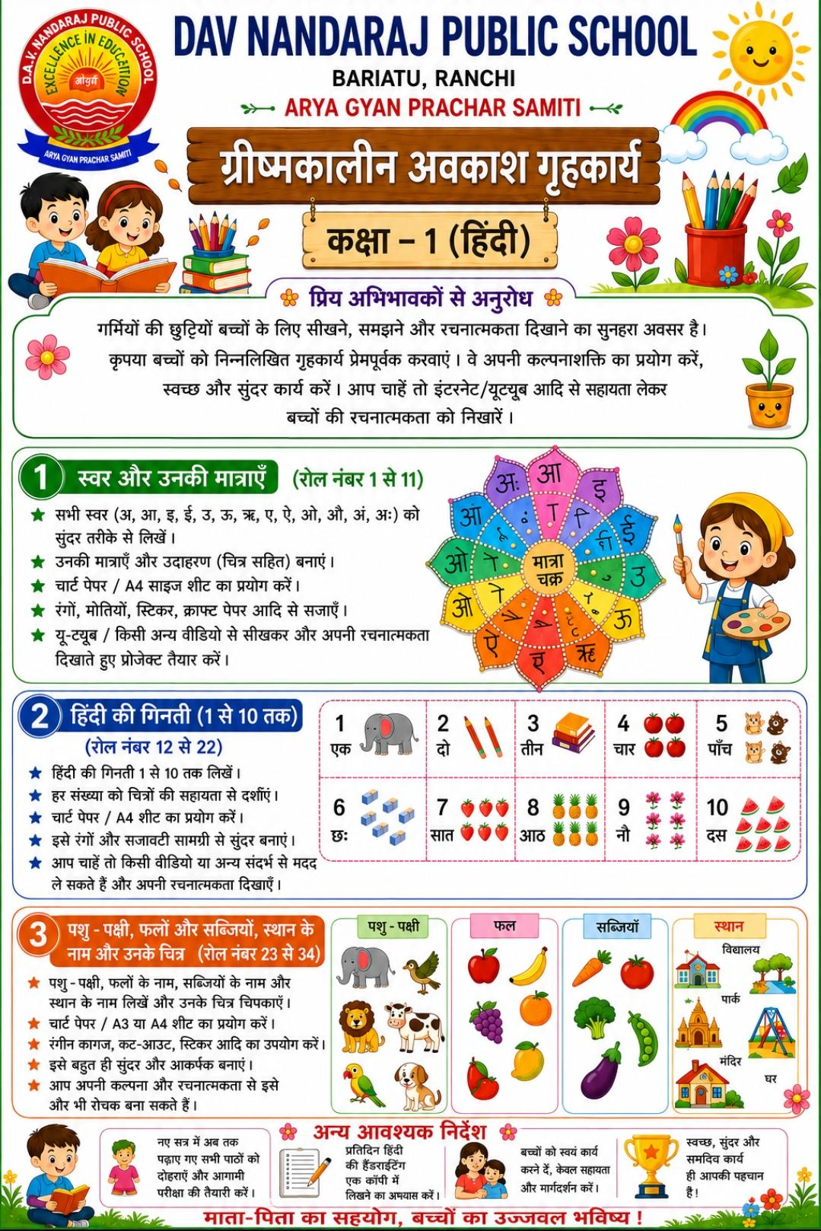
HINDI
EVS
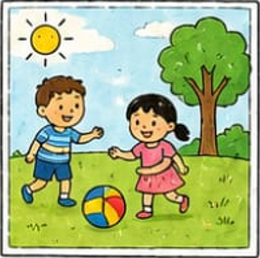 | a) Learn all the notes and textbook exercises of Ch 1,2,3 and 4.  b)🍎 Healthy Habits Chart  Make a colourful chart,paste the pictures showing any 5 healthy habits:  Wash hands before eating  Eat fruits and vegetables  Drink plenty of water  Exercise daily  Sleep on time

COMPUTER
 | - Learn Chapters 1 and 2.  - Draw 4 natural and man-made things on A4 sheet.

GK
- Draw, label and colours a plant on A4 Sheet.
- Learn Chapters 1 to 8.
VEDIC EDUCATION
1-प्रतिदिन दादी से कहानी सुनना है और उससे मिली शिक्षा का पालन करना है ।
2- प्रतिदिन छत पर एक बर्तन में चिड़िया को पानी देना है तथा किसी दो दिन की फोटो फाइल में चिपका कर लाना है ।
3- अंतिम पाठ से झंडे के बीच का चक्र ए4 साइज के पन्ने पर बनाना है ।

✨ INSTRUCTIONS ✨

- Do the work neatly in a separate rough notebook.
HAPPY HOLIDAYS & HAPPY LEARNING!
- Use colours, stickers, and pictures wherever possible.
- Parents are requested to guide the child.

